Cyberball Hosting Manual
  - May 2026—Version 6.0.0

Maintenance 4
GitHub and Visual Studio Code 4
Websites 4
Login 4
SFTP Access 5
WinSCP 6
Updating Cyberball 7
Assets 7
Location 8
Presets 9
Manual 13
QSF 14
Defaults 14
Location 14
Updating Settings 15
Updating Portraits 16
Development 17
GitHub 17
Model-View-Controller (MVC) Design 17
Included Files and Functions 19
Adding a Module 19
Test Framework 20
Web Framework 21
Design 21
Initial Setup 22
Local 22
Server 23
Qualtrics 23
Setup 23
Data Output 26
Different Use Cases 32
Known Bugs 33
Future Items 33

Maintenance
This section is documentation about the process of maintaining Cyberball in such detail that a nontechnical audience should be able to understand and complete these actions. It covers details relating to GitHub, the website, the assets, and the default settings.

GitHub and Visual Studio Code
This section will explain the basics of how to interact with GitHub and Visual Studio Code (VSCode) for a non-technical user. If you understand the usage of Git, GitHub and VSCode, then you can skip this section of the manual.
Git is a version control system often used in software systems. It keeps track of changes to files in small “commits”. This allows storing the full history of the software development process.
GitHub allows for two different ways of contributing code if you want to make changes to Cyberball. You can either create an issue or pull request on the official Cyberball repository, or you can fork the repository to create your own version. It would be advisable to create a fork of the repository to make changes and provide updates before pushing it to the official GitHub and official website.
VSCode allows the ability to easily make changes, see those changes, and update a GitHub repository. It is important to understand how GitHub and VSCode work if you are looking to make substantial changes. This article, this article, and this article explain everything needed to know to make changes (or provide a resource to find deeper documentation if needed).

Websites
Cyberball uses the Ohio State University's (OSU) dedicated web hosting service for managing and deploying the application. Researchers working on this project need appropriate server access to upload files, manage website settings, and deploy new features or updates.

Login
Use your OSU credentials to log into the OSU website administration control panel. Ensure you use your OSU username and password to access the website control panel.

SFTP Access
This section checks to make sure you are authorized for Secure File Transfer Protocol (SFTP) access to the Cyberball websites, it may need repeated for each website (DEV, TEST, and PROD).
- Select ‘SFTP/SVC’ on the lefthand sidebar.
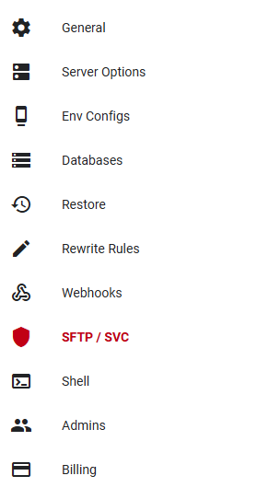
- There is a list of authorized users, if your account isn't already added, click "Add New SFTP Account”. Enter your ‘name.#’ for the username and “/” for the chroot (like the other accounts on the list).
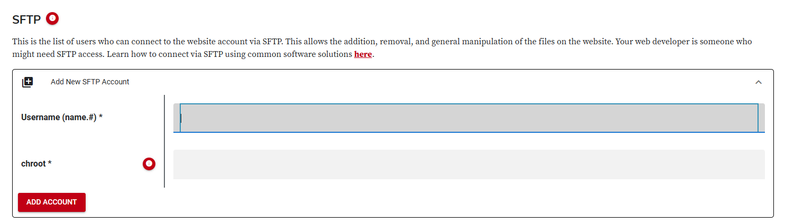
- Click “Add Account”.

WinSCP
WinSCP is a free and open source SFTP, FTP, WebDAV, S3 and SCP client for Microsoft Windows. WinSCP is recommended for secure and convenient file transfers between your local computer and the OSU server. The first step will be to download and install a client for pushing files to the web hosting servers.
After running WinSCP for the first time, it opens the Initial Connection Manager.
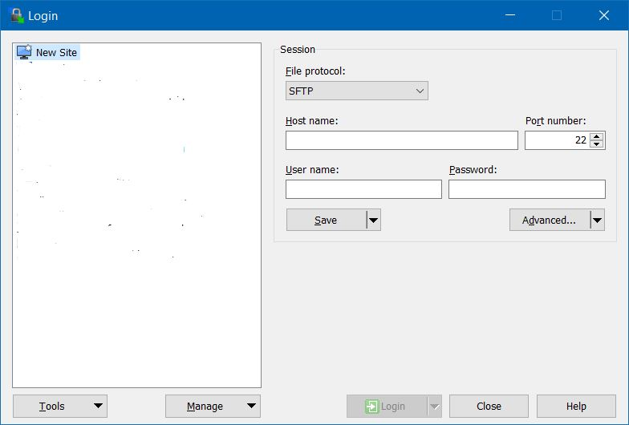
The login session should be configured as follows.
- File Protocol
  - SFTP
- Host Name
  - web.osu.edu
- Port Number
  - 22
- Username
  - a string built from your name.#, an ‘@’ symbol, and the remote website’s account ID (the OSU web hosting name)
    - For example, name.#@cyberball-dev or name.#@cyberball-test
- Password
  - your name.# OSU password

Updating Cyberball
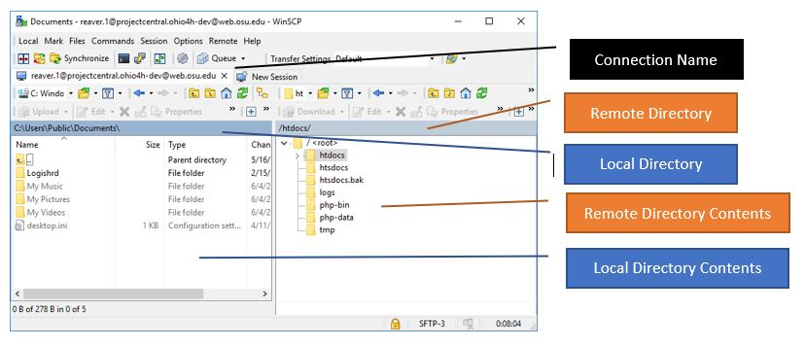Upon connecting to the OSU development server via WinSCP, you will primarily interact with the htdocs directory which contains the running Cyberball web application.
The server is configured to automatically serve the content placed inside the htdocs folder. Therefore, updating the Cyberball websites simply requires replacing all the files inside htdocs with the latest version of your code.
Because of server-side caching mechanisms, replacing only a few modified files might not immediately reflect the updates. So, it is strongly recommended to replace the entire htdocs folder, even if you only made minor changes.
After updating the server files, users might still see old versions of the website because their browsers cache static assets (such as JavaScript, CSS, and images). To ensure the new changes are visible, users should clear their browser cache manually. This is how to on Google, Firefox, and Edge.

Assets
This section contains information about the location of the assets on Cyberball with information on the easiest way to fix or update the assets. The location and how to edit assets are the same in VSCode, it is only a different interface and allows you to locally see changes before publishing to a website. A recommendation is to look at the GitHub and Visual Studio Code section and Initial Setup section.

Location
The easiest way to access the location of these assets is through the official Cyberball GitHub. From there, the assets are all located in the folder labeled assets. It does not matter what version of GitHub; these should always be in that folder.
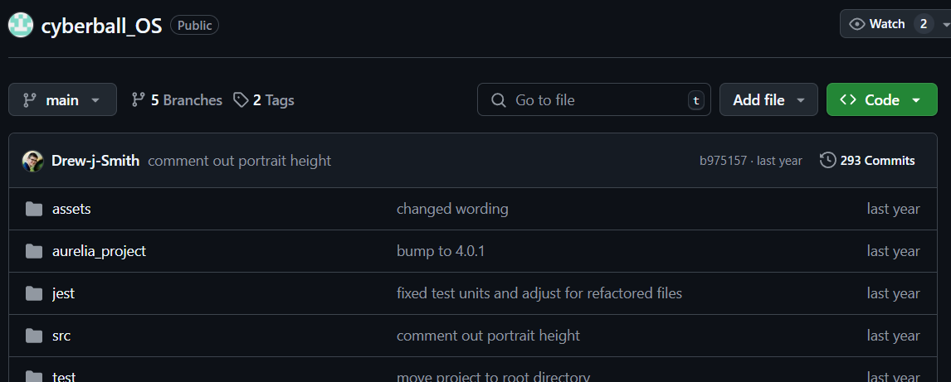
Once you open that folder, a list of all the assets used in Cyberball will appear.
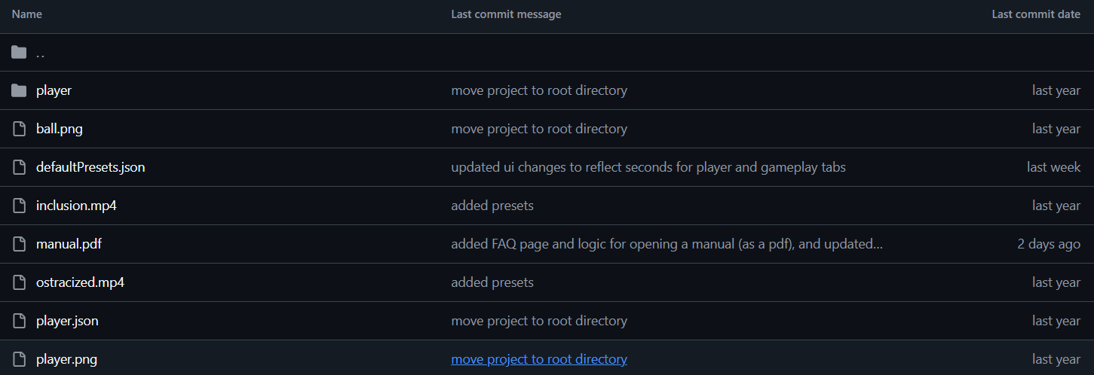
The following is a description of each of the current assets found in the folder at the time of writing this document.
- player — a folder containing all the sprites and animations for the characters.
- ball.png — the picture of the ball that is thrown.
- cyberball_qualtrics.qsf — a file for easy integration with Qualtrics.
- defaultPresets.json — a list of presets shown on the “Load Presets” page.
- inclusion.mp4 — the video for the “Inclusion Game” preset.
- manual.pdf — the user manual on the “Help” page.
- ostracized.mp4 — the video for the “Ostracized Game” preset.
- player.json — a file for helping the player character move between the sprites.
- player.png — the banner of player stages shown on the top of each page.
- slow_player.mp4 — the video for the “Slow Player Game” preset.
In general, the only assets you need to be aware of for the rest of this section in the manual are defaultPresets.json, cyberball_qualtrics.qsf, inclusion.mp4, ostracized.mp4, slow_player.mp4, and manual.pdf.

Presets
This section contains specific instructions for adding, deleting, and updating the presets shown on the “Load Presets” page on the “Presets” tab. You will need access to defaultPresets.json and be aware of the location of inclusion.mp4, ostracized.mp4, and slow_player.mp4.

Adding
This section contains the process for adding a preset to Cyberball.
Configure a game of Cyberball as desired by using the configuration builder. On the export page of the builder, click “Download”. Save the file with any name and in any place that you will find it. The .txt file contents should look like this after opening:
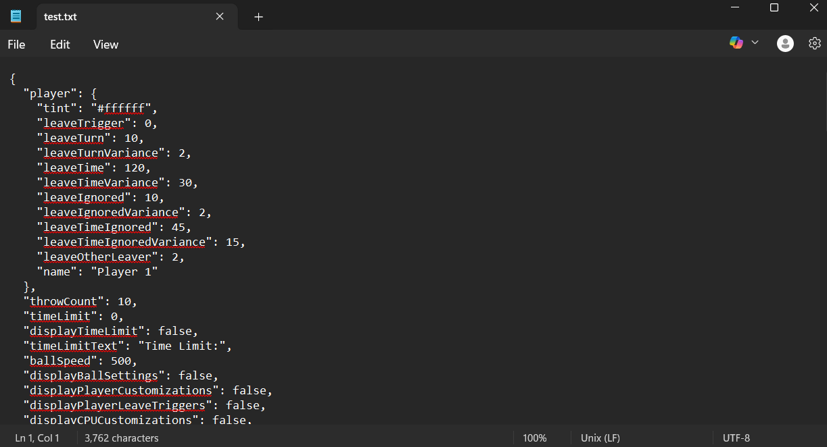
Now, select and copy all the contents from this file. Open defaultPresets.json and switch to the editor mode. We are going to add another JSON object at the end of the defaultPresets.json to put in the new preset. The very end of the JSON file should look like this:
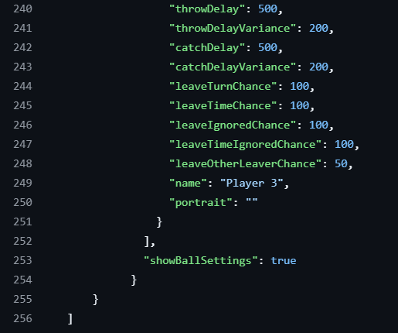
In this location, we want to add a comma and another set of curly brackets, like this:
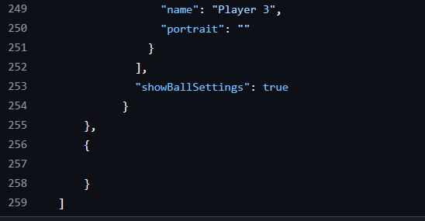
The new JSON object we are creating needs four keys: name, description, video, and settings. Add these keys inside those new curly brackets and give them temporary values.
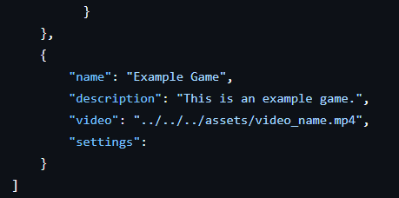
The temporary values for name and description should be filled in with what is representative of the preset being added. For video, a video in MP4 format needs to be uploaded to the assets folder, in the list of assets shown earlier (with inclusion.mp4, ostracized.mp4, and slow_player.mp4—videos for current presets). This video is a screen recording of the preview that loops beside the preset’s description to give a visual understanding of the game. Rename the video_name part of the value to the name of your video and we will upload the video to the assets folder after we save changes to the JSON file. For settings, we will paste the entire .txt file we copied earlier.
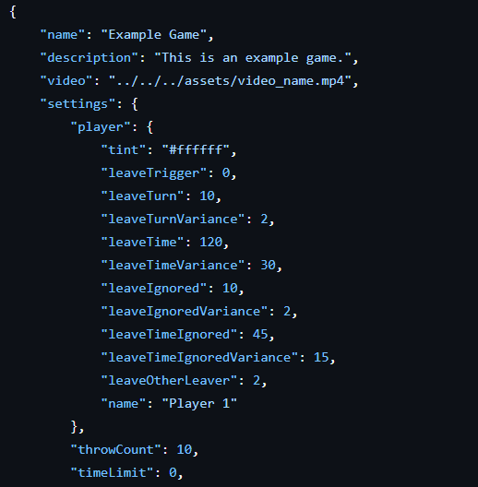
This should add all the lines from the .txt file into defaultPresets.json. It should now be properly formatted, and you can click on “Commit Changes” at the top of the GitHub page to save the changes. It is important to give a detailed description of what has changed so other people are aware of what you did.
To add the video that we encoded into defaultPresets.json, simply add it to the assets folder by uploading the file by clicking on the ‘Add file’ button.
Once defaultPresets.json has been saved, the video has been uploaded, and the server has been updated, the preset should appear.
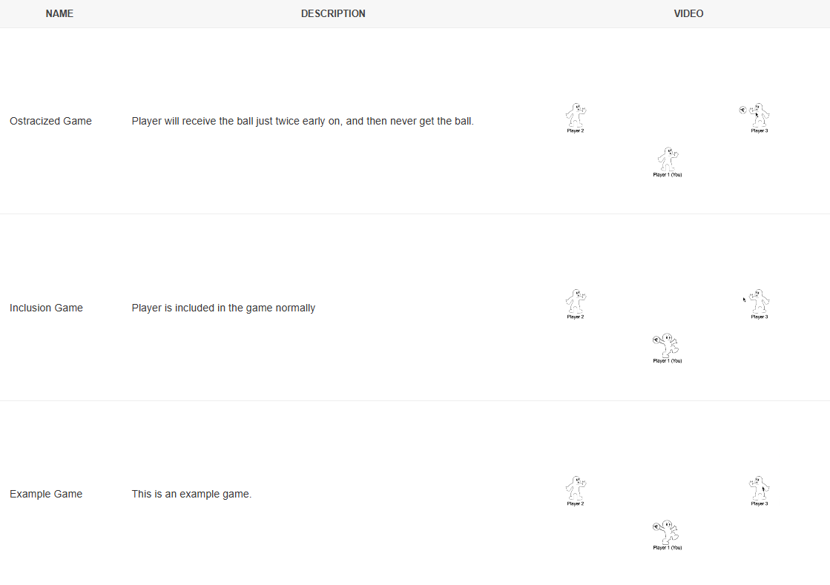

Deleting
This section contains the process for deleting a preset to Cyberball.
The process for deleting a preset is easier than adding one. Simply open defaultPresets.json and remove all the contents corresponding to one of the JSON objects. You’ll remove everything from the curly brace above the “name” row all the way down to the curly brace with a comma that has the same indentation level.
You’ll remove everything in between the set of curly braces; it should appear in an invisible second column. From the curly brace above the “name” row all the way down to the curly brace with a comma in that same column
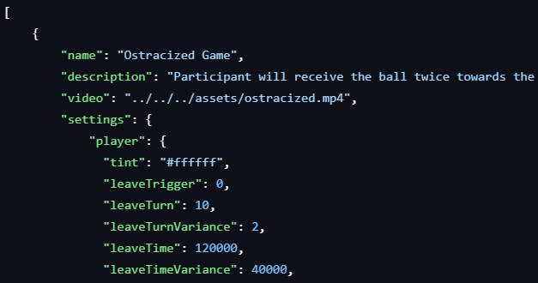
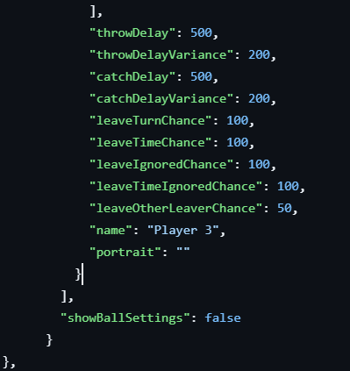
This should remove all the lines from defaultPresets.json relating to that preset. It should not be properly formatted, and you can click on “Commit Changes” at the top of the GitHub page to save the changes. It is important to give a detailed description of what has changed so other people are aware of what you did.
To remove the video, click on the ‘...’ button and click ‘Delete file’.
Once defaultPresets.json has been saved, the video has been removed, and the server has been updated, the preset should disappear.

Manual
This section contains information on updating the user manual found on the “Help” page in Cyberball.
Rename the new version of the manual to manual.pdf (this is character and case sensitive), and click ‘Add file’, and replace the file found in the repository already.
Once the file is changed, you will have to update the websites as with other assets.

QSF
This section contains information for updating the .qsf file found on the export settings page in Cyberball.
Rename the new version of the .qsf to cyberball_qualtrics.qsf (this is character and case sensitive), and click ‘Add file’, and replace the file found in the repository already.
Once the file is changed, you will have to update the websites as with other assets.

Defaults
This section contains information about the location of the defaults on Cyberball with information on the easiest way to fix or update the defaults. The location and how to edit defaults are the same in VSCode, it is only a different interface and allows you to locally see changes before publishing to a website. A recommendation is to look at the GitHub and Visual Studio Code section and Initial Setup section.

Location
The easiest way to access the location of these defaults is through the official Cyberball GitHub. From there, the defaults are all located in the folder labeled types in the src folder. It does not matter what version of GitHub; these should always be in that folder.

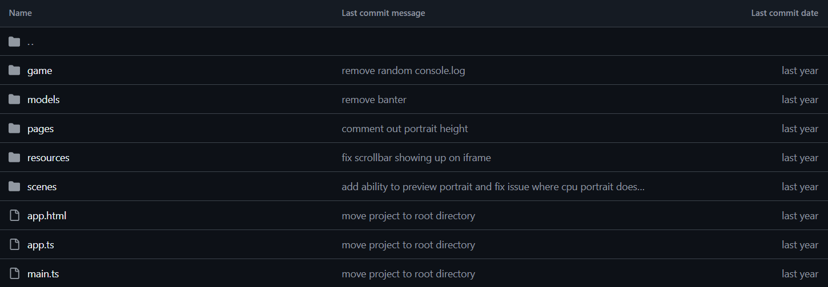
Once you open that folder, a list of all the files with the defaults used in Cyberball will appear.
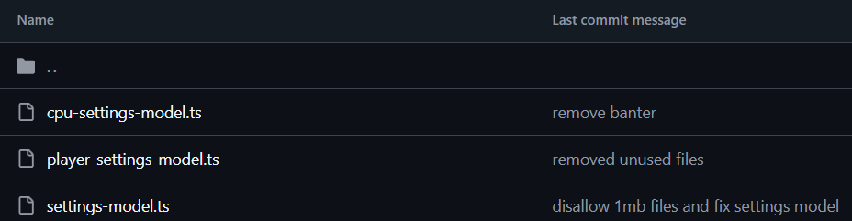
The following is a description of each of the current files found in the folder at the time of writing this document.
- Settings.ts — the file that contains the type definitions and default values for all settings in Cyberball, including CPU settings, player settings, and general game settings.

Updating Settings
This section contains information about updating the settings that auto-populate on the configuration builder pages.
To update any settings on the configuration builder pages, simply edit the corresponding file and values.
You can click on “Commit Changes” at the top of the GitHub page to save the changes. It is important to give a detailed description of what has changed so other people are aware of what you did.
Once the file has been saved, and the website has been updated, the settings should be updated.

Updating Portraits
This section contains information about updating the default portraits that appear on the configuration builder pages.
Before updating default portraits, ensure that your images are hosted online and have accessible URLs. You can use this, or any reliable image hosting platform. Make sure these URLs are public and accessible.
Open settings-model.ts and inside the file, locate the following array definition:
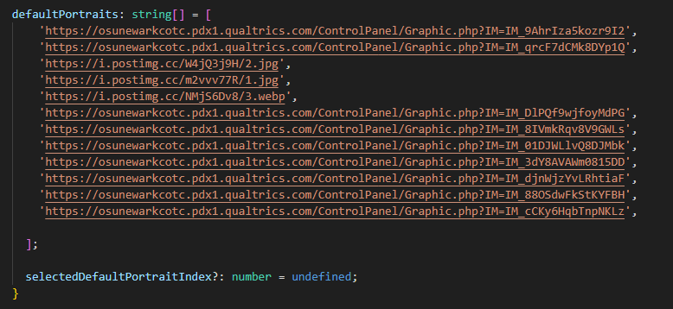
Replace or append your new URLs into this array. Note that the portraits will appear in the same order as they are listed in this array, meaning the first URL corresponds to the first default portrait displayed in-game, and so forth.
You can click on “Commit Changes” at the top of the GitHub page to save the changes. It is important to give a detailed description of what has changed so other people are aware of what you did.
Once the file has been saved, and the website has been updated, the portraits should be updated.

Development
This section is documentation about the process of development for Cyberball in such detail that a new development team should be well adjusted after reading. Cyberball is built into two sections, the game and the website. While not entirely distinct from one another, this section focuses on the architecture and functions of the game which is built on Phaser. It includes discussion of several technical concepts, including but not limited to TypeScript, the Model-View-Controller and the Observer design patterns, and Callback Functions. Please familiarize yourself with these concepts if you are not already familiar.

GitHub
It would be advisable to create a fork of the official Cyberball repository to make changes and provide updates before pushing it to the official GitHub and official website.

Model-View-Controller (MVC) Design
Cyberball is built in an MVC design pattern and runs off Phaser. However, the entire Phaser package is managed by React. For understanding the game and the construction, only one file managed by React is relevant, GamePage.tsx. This file functions as the game initializer by constructing the game model(s), importing the models into the controller, linking the controller with the view, and setting up all controller callbacks. Once the game is running, it is no longer called.
Beyond this, files are grouped into four categories, Model, Controller, View, and Helper. The model files hold information about a game state or game action. These are read by the Cyberball Game Controller which facilitates all game logic either internally or by using callbacks. The callback system allows for modular game functionality. Each module and feature are given their own file, and each event in the game has their own dedicated callback list. The single view file, cyberball.ts, runs the Cyberball Scene through Phaser. A few helper files provide code used by other files to properly execute their function.
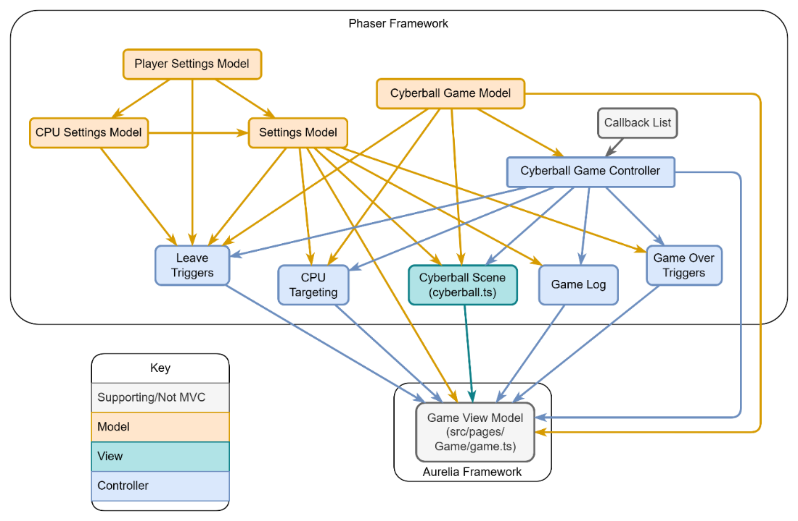
Figure 1. Cyberball Game File Architecture. (Arrows Indicate Imports) (Example → Imports Example)
When considering the overall structure, the only element that needs further discussion is the callbacks system. Whenever a game event occurs, for example, any player throwing the ball, the corresponding callback list runs. The callback lists are populated during the initialization of the game. The add(blank)Triggers() functions in Figure 2 are all called within game.ts. Generally, every game function, aside from core functions, is built in their own module and called using their corresponding add(blank)Triggers() function. The callback functionality is discussed further in the Adding a Module section.
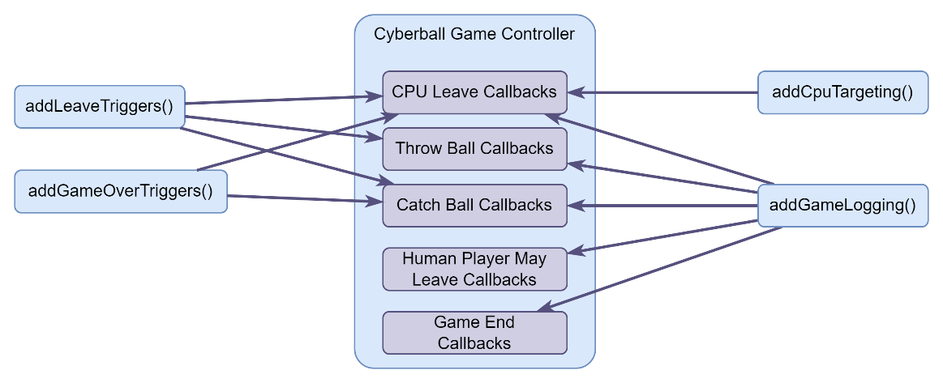
Figure 2. Cyberball Game Controller Callbacks and Feature Modules.

Included Files and Functions
- GamePage.tsx (osuCyberball\src\pages\GamePage.tsx)
  - initializes the game, as described prior
- Cyberball Game Model (osuCyberball\src\game\CyberballGameModel.ts)
  - contains the current game-state data, this is updated in real-time as the game progresses
- Settings Model (osuCyberball\src\types\Settings.ts)
  - contains the main configuration data, this is populated by whoever sets the desired game settings on the configuration builder website
- CPU Settings Model (osuCyberball\src\types\Settings.ts)
  - contains the CPU configuration scaffold used for each CPU instance
- Player Settings Model (osuCyberball\src\types\Settings.ts)
  - contains the human player configuration data
- Cyberball Scene (osuCyberball\src\scenes\cyberball.ts)
  - controls the visuals for the game through the Phaser engine
- Cyberball Game Controller (osuCyberball\src\game\CyberballGameController.ts)
  - primary logic controller, contains the callback lists and facilitates running them at the appropriate times
- Callback List (osuCyberball\src\game\callback-list.ts)
  - custom package to manage series of callback functions
- Leave Triggers (osuCyberball\src\game\LeaveTriggers.ts)
  - sets up the leave trigger callback functions, affect both the human player and CPUs
- CPU Targeting (osuCyberball\src\game\CpuTargeting.ts)
  - manages CPU scheduling
- Game Log (osuCyberball\src\game\GameLog.ts)
  - sets up callback functions to populate and publish the game log for Qualtrics data capture
- Game Over Triggers (osuCyberball\src\game\GameOverTriggers.ts)
  - sets up callback functions to manage game over conditions and ensure logic ends properly

Adding a Module
This section details how to add a new code module to the game. The existing modules include logging, CPU targeting, leave triggers, and game over triggers (all the game logic except for catching, throwing, and leaving).
The best way to see how to add a module is by looking at the existing modules, they provide a good framework for creating a module.
The main aspect of a module is to add callbacks to the controller. There are 5 different callbacks available (although it is likely you will only be interested in a subset). The five callbacks available are CPU leaving, throwing the ball, catching the ball, the human player is allowed to leave, and the game ends. So, for example, if you wanted to do something when someone catches a ball it would look like below. Once you create the module, you need to make sure that it gets called with the rest of the modules in game.ts.
controller.catchBallCallbacks.addCallback("Unique logging name", () => {
// something
});

Web Framework
The web framework used to initialize the game and host the website is React, with Vite as the build tool. React uses TypeScript to create reusable UI components written in TSX (TypeScript with JSX syntax). For Cyberball, React’s component-based architecture is used to build each page of the website. State is managed within components using React hooks (such as useState and useEffect) and passed to child components as props. React Router is used for client-side routing between pages. Vite handles bundling and provides a fast local development server.

Design
All files and folders discussed in this section are within the folder osuCyberball\src\.
All routing is defined within App.tsx. The file main.tsx is the entry point that renders the App component into the DOM. All the pages that are referenced in the router are found in the pages folder. The components folder contains shared UI components that are reused across pages. The game folder contains all game logic files (also described in the Included Files and Functions section above). The scenes folder contains the Phaser scene definition. For testing, Jest is used as described in the Test Framework section.

- Landing Page
  - the first page when loading the website
  - found in osuCyberball\src\pages\LandingPage.tsx
- Home
  - the page seen after selecting “Create New” on the landing page
  - found in osuCyberball\src\pages\Home\
  - the file HomePage.tsx defines the entire page
  - the file PlayerTab.tsx defines the “Human” settings
  - the file CpuTab.tsx defines the “CPUs” settings
  - the file GameplayTab.tsx defines the “Gameplay” settings
  - the file ButtonTab.tsx defines the export settings
  - all files styled by homePage.css in pageSpecificCSS\
- Game
  - defines the Iframe containing the game
  - found in osuCyberball\src\pages\GamePage.tsx
  - the game itself is defined in osuCyberball\src\scenes\cyberball.ts
- Presets
  - the page seen after selecting “Load Presets” on the landing page
  - found in osuCyberball\src\pages\LoadPresetPage.tsx
- Help
  - The page seen after selecting “Help” on the landing page
  - Found in osuCyberball\src\pages\HelpPage.tsx

Initial Setup
You need NodeJS installed to run this project. Make sure to have it installed before continuing.
After downloading the repo, navigate into the osuCyberball folder. You will need to do this in a system terminal. Once in the osuCyberball folder, run the following commands in order. Please note, several of these take some time to finish.
Run npm i in the console to install dependencies.

Local
Run npm run dev to run the website locally.

Server
Run npm run build to build a static webpage for a web server. Copy all the files inside the dist folder to a web server.
You should not have to worry about caching issues because the JavaScript bundle has a hash included in the file name.

Qualtrics
Cyberball is most used within Qualtrics, Qualtrics is a platform used for creating and distributing surveys to collect data and analyze results. This is the most common way that Cyberball will be administered. The explanation below will provide a base case to embed Cyberball within a question in Qualtrics.

Setup
- Log in to your Qualtrics account.
- Set-up a Qualtrics survey and identify where you want to add the embedded game.
- Click ‘Add new question’ and select ‘Text/Graphic’.
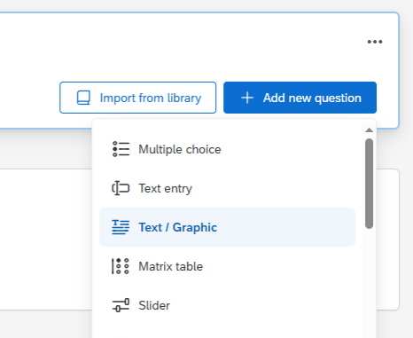
- Click on the default text in the question box, this should open the editor.
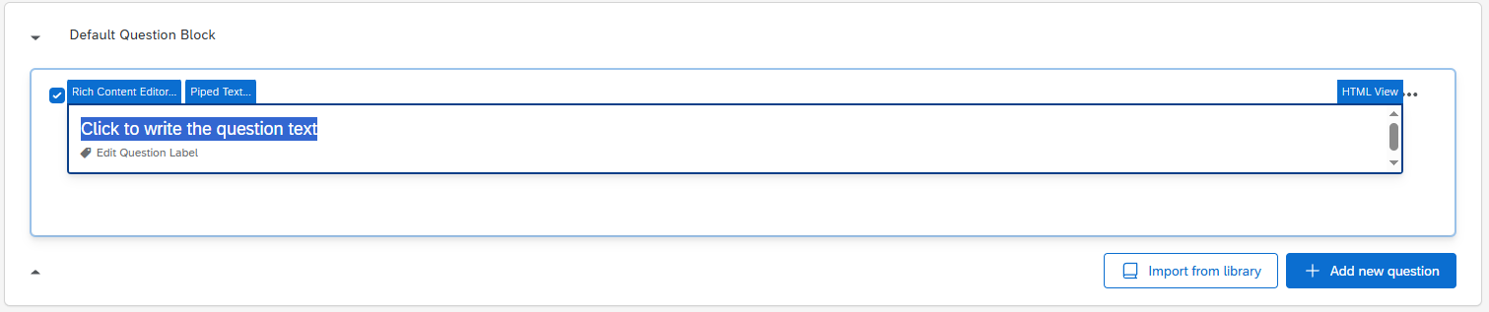

- Click on ‘HTML View’ in the top right of the text editor.
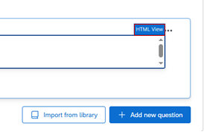
- Paste the embedded game data from the configuration website (“Copy Embed Code”). Or copy the following, replacing the URL with your custom game URL:
<iframe id="cyberball" width="100%" height="580" src="https://cyberball-dev.org.ohio-state.edu/#game?settings=..."></iframe>
- Click back into ‘Normal View’. The embedded game should be visible.
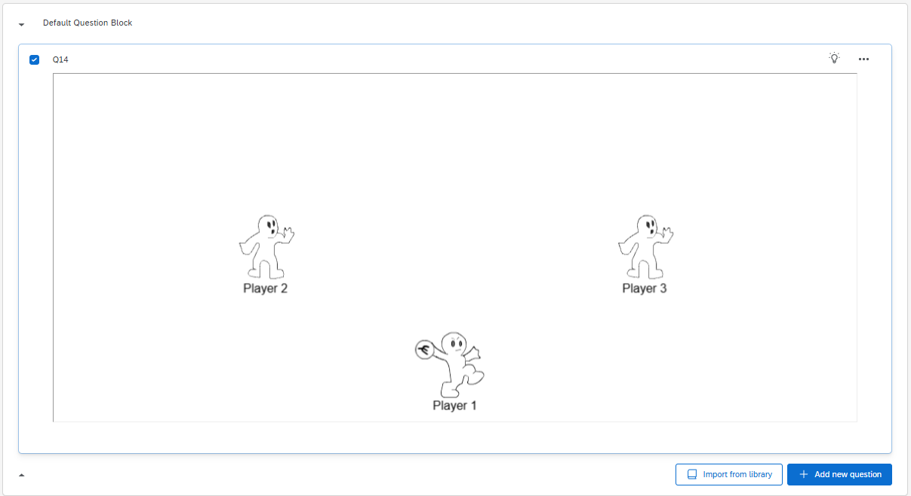

It is important to note that once a game is embedded, it is difficult to reopen the editor. To do so, hover over the game. You should see a gray border appear. Click on the bottom of this.
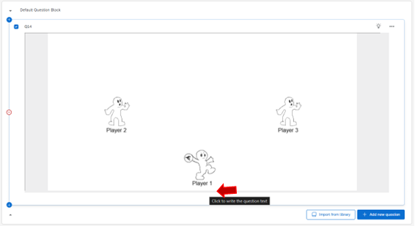
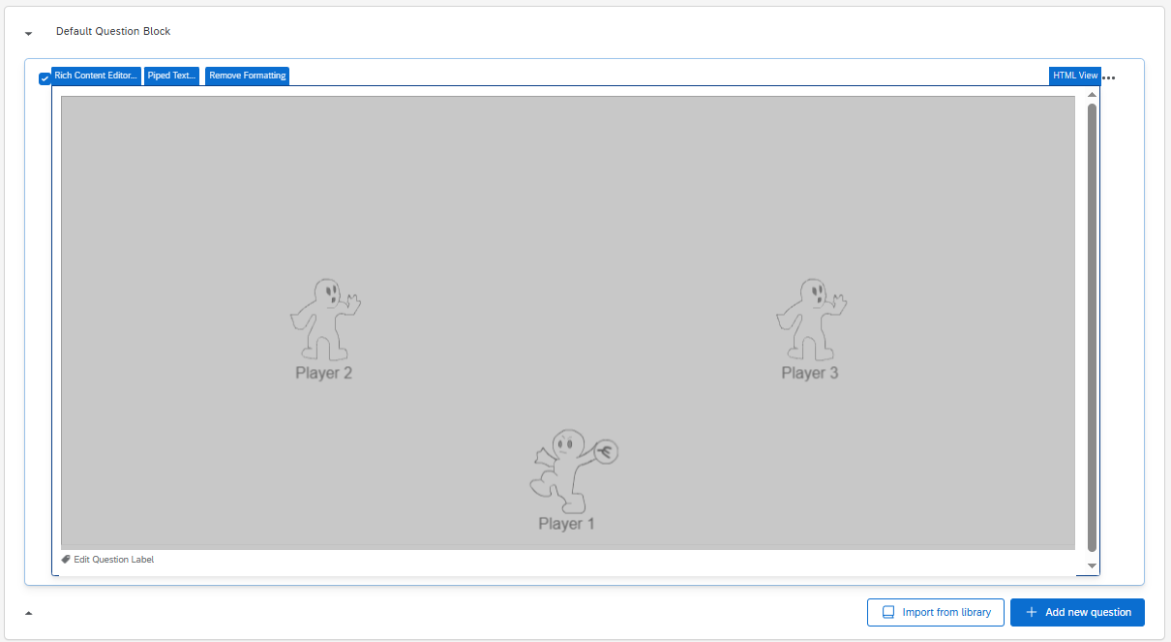
If you are unable to reopen the editor for any reason, you should be able to quickly delete and re-add the question using the steps shown before.

Data Output
After embedding the Cyberball game within a Qualtrics question, you must add the embedded JavaScript and custom data fields to the survey to collect the data from the game. This data includes a log of the duration of the game, throws, and more. After a published survey is set up using the instructions below and has recorded responses, you can download the data in multiple formats. Another alternative to following the instructions below is to download the provided .qsf file on the Export Settings page and import them. This link is a tutorial from the Qualtrics website.

Data Fields Setup
This section is critical as without data fields, there will be no game data collection saved by Qualtrics. This section is case-specific so be sure to check capitalization.
- Click ‘Survey flow’ on the left control panel.
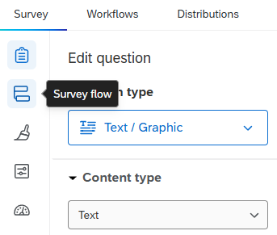
- Click ‘+ Add a New Element Here’ and select ‘Embedded Data’.
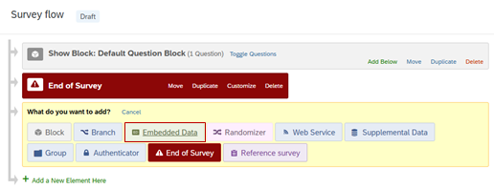
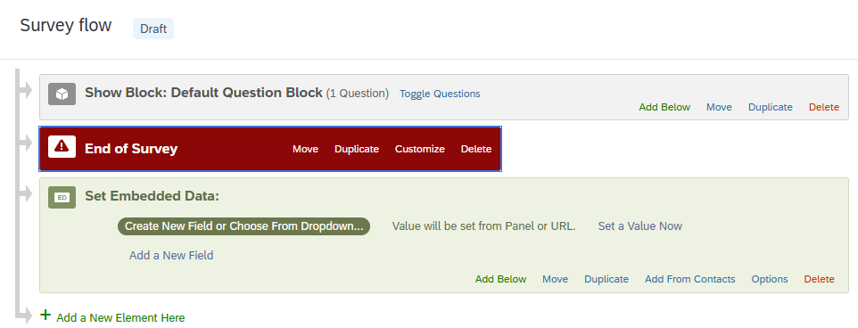
- The following fields need to be added exactly as typed as the fields are case and character specific.
  - game_log
  - throws_formatted
  - Player_1_to_Player_2
  - Player_1_to_Player_3
  - Player_1_to_Player_4
  - Player_2_to_Player_1
  - Player_2_to_Player_3
  - Player_2_to_Player_4
  - Player_3_to_Player_1
  - Player_3_to_Player_2
  - Player_3_to_Player_4
  - Player_4_to_Player_1
  - Player_4_to_Player_2
  - Player_4_to_Player_3
  - total_throws
  - player_may_leave
  - total_time

- Also, it is a good idea to add a Condition field that you manually set to match your game type. If you want, you can set other fields to be certain data types, but this is optional.
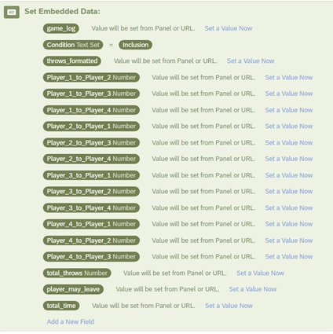

Data Field Descriptions
- game_log
  - the full event list of what happened in the game and when
- throws_formatted
  - a 2D array of throws from any player to any other player
    - arr[player_A - 1][player_B - 1] is the number of throws from A to B
    - the human player is always Player 1 and therefore index 0
- Player_A_to_Player_B
  - number of throws from player A to player B
    - limited to the first four players
    - pulled out of throws_formatted for easier access and use
- total_throws
  - total number of throws from anyone to anyone in the game
- player_may_leave
  - when in the game the player is given the option to leave
- total_time
  - total duration of the game

Embedded JavaScript
Once a Cyberball game is embedded and data fields are set-up, the last step is adding the embedded JavaScript.
- Click on the Qualtrics survey question containing the embedded game.
- On the question, right click and select ‘</> Add JavaScript’ or click ‘</> JavaScript’ on the left.
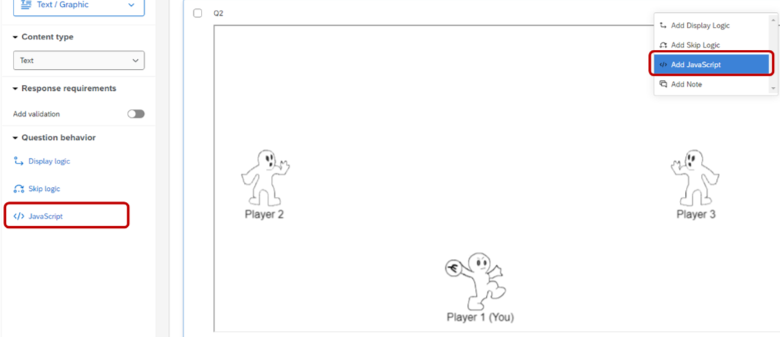
- This pop-up window should appear.
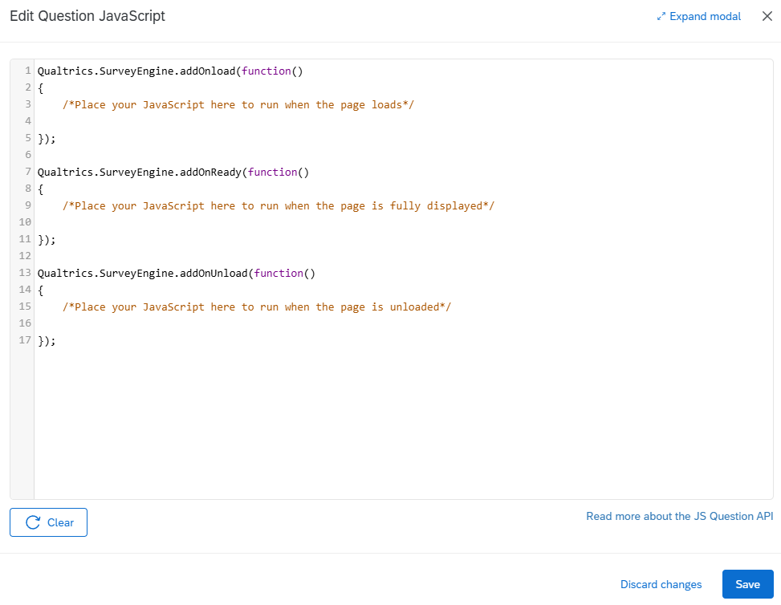

- Paste the following in the pop-up window.
- Qualtrics.SurveyEngine.addOnload(function() {
- this.hideNextButton();
- });

- Qualtrics.SurveyEngine.addOnReady(function() {
- let that = this;

- function handleSurveyMessage(msg) {
- // Ignore anything that isn't our game data
- if (!msg.data || typeof msg.data !== 'object') return;
- if (!msg.data.game_log) return;

- for (const [key, value] of Object.entries(msg.data)) {
- if (key === "player_throws_list") {
- for (const [throwPath, numThrows] of Object.entries(value)) {
- Qualtrics.SurveyEngine.setEmbeddedData(throwPath, numThrows);
- }
- } else {
- Qualtrics.SurveyEngine.setEmbeddedData(key, JSON.stringify(value));
- }
- }

- setTimeout(() => {
- that.clickNextButton();
- }, 3000);
- }

- window.addEventListener('message', handleSurveyMessage);
- });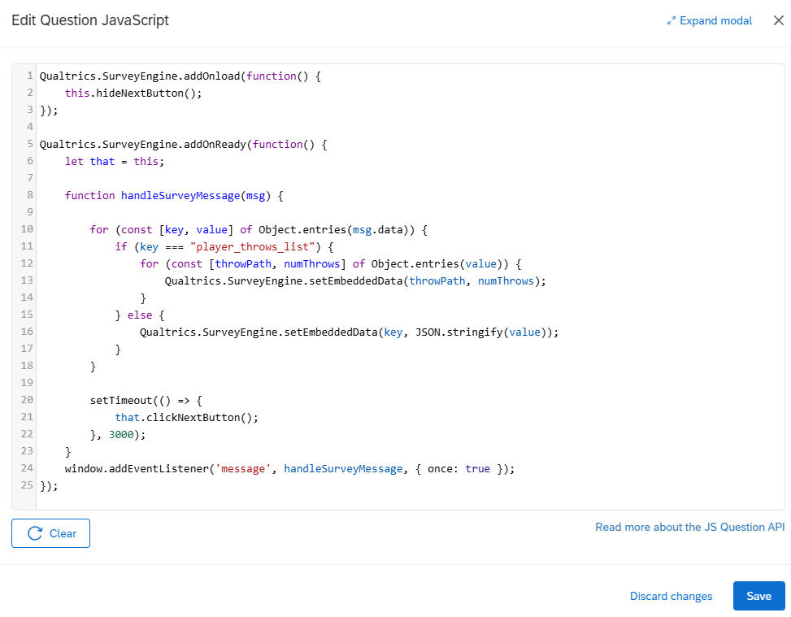
- Click ‘Save’ on the bottom right of the pop-up.

Downloading Results
- Click on ‘Data & Analysis’ at the top.
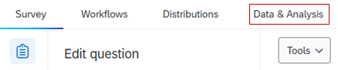
- Hit ‘Export & Import’ on the right, then select ‘Export’.
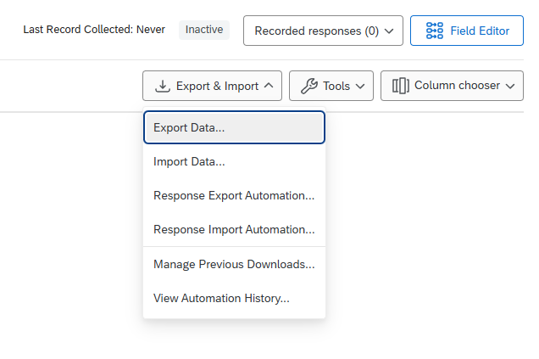
- Click the format you want to export the data as, then hit ‘Download’.
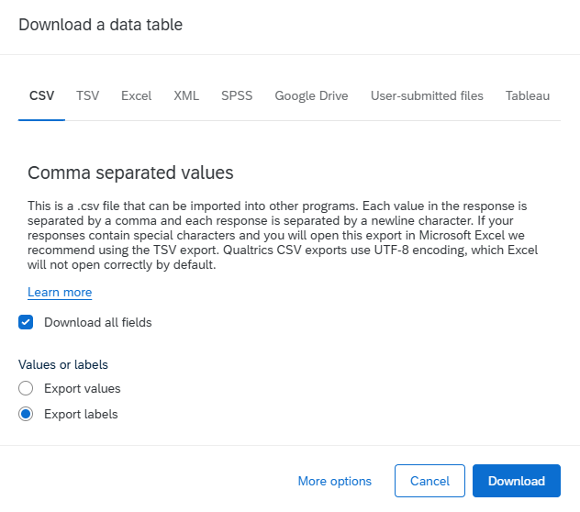

Different Use Cases
As of right now, Cyberball is most used as one question within a Qualtrics survey. However, Cyberball can also be used in a linked survey and embedded multiple times in a single survey. Note: With only one instance of Cyberball in a survey, it will record the data as expected (both true for a standalone and linked surveys). However, if a survey contains multiple instances of Cyberball as questions, it will not properly record the data for each instance. Instead, it will only record the data for the last instance.

Future Items
- Image Hosting
  - A future team could set-up a system to host the player portraits remotely (on a browser, server, etc.)
- Reworked Portrait Feature
  - A future team could rework the feature to not rely on URLs.
- Demo Mode
  - This would be a mode where you can control all players in the game.
  - This could be possible by unifying the player/CPU and also making it easier to test.
- Updating the Scheduler UI
  - A future team could rework the UI for it to be more intuitive to use, a few ideas are provided after this section.
- Change the embedded JavaScript within Qualtrics such that it can record the data for a single survey with multiple instances of Cyberball.

Scheduler Mock UI 1 (SP24 Team)
This first mock was more interesting in function over form. As such it uses default styling that would need to be updated. The way this scheduler works is because each row represents a throw, and you specify who each player will throw to. From the diagram it may not be initially clear what is happening, but I think with proper error messages and tuning to the UI I think this could be an effective system.
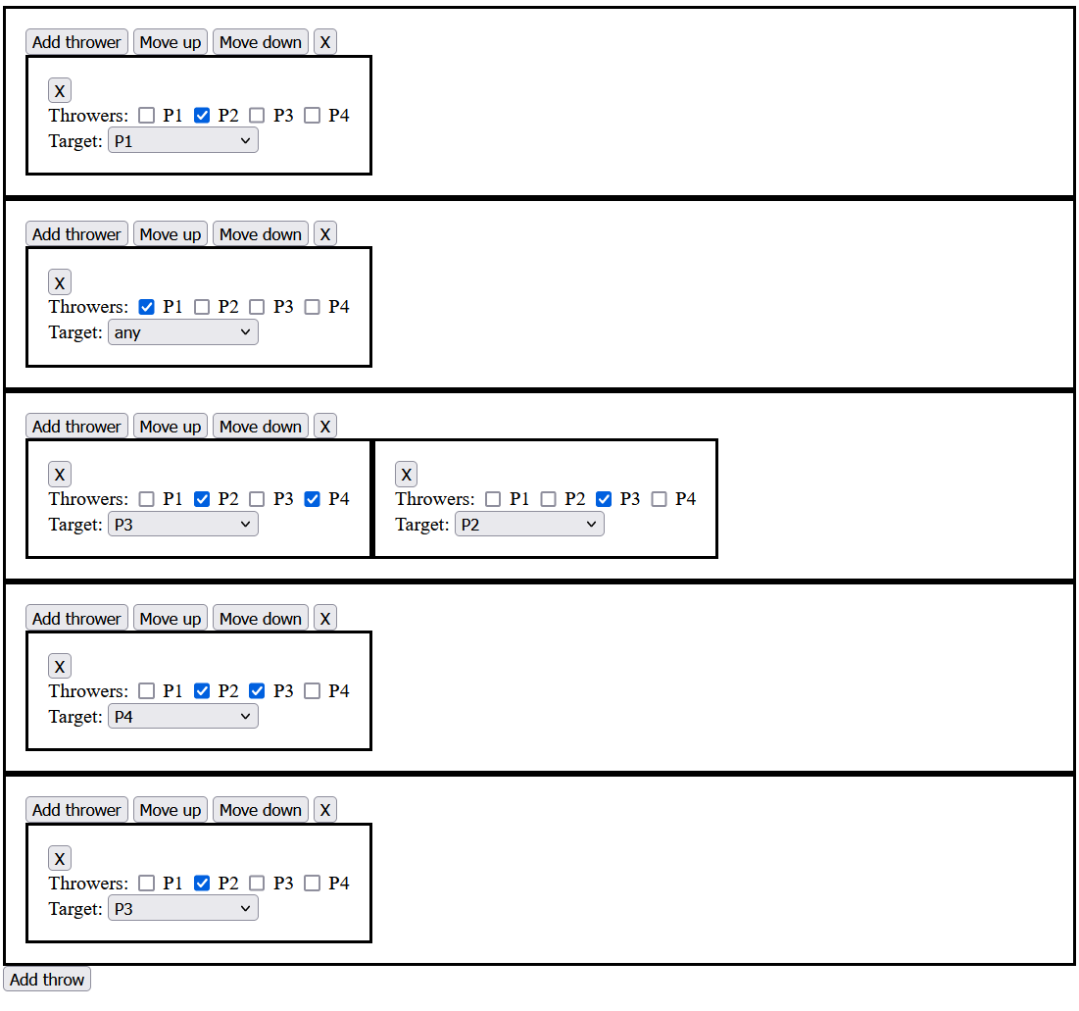
So as stated previously, each row represents a throw in the game. And it checks who is holding the ball to see where the ball should be thrown next. So, let's trace through what a game might look like for this schedule. Player 2 starts with the ball. They throw it to Player 1 (the human player). The player can throw it at any player (so any must be chosen as the target in the schedule). Then on the next throw any CPU player may have the ball. If the player threw to player 2 or player 4. They will throw it at player 3. If the player throws it to player 3, then the CPU will throw it to player. For the next throw the CPUs will throw player 4. For the last throw player 4 will throw to player 3.
The advantage of this system is that throws are never skipped, you can always see which throw is happening. This system does not allow for randomization like the current system.
There are a couple of ways that this system could be improved. One of them is to make it harder to make complex games. Instead of allowing full control you would constrain it to a few types of throws. 1. Single CPU to CPU. 2. Throw it to player 3. Player throw. 3. Funnel to single CPU (this would function like the two middle throws, CPUs throwing to one of two options and then throwing to a single CPU). Another possibility is to be aggressive about warnings to the user when they are doing something that is atypical. E.g. warning if they have a CPU listed twice as a thrower in a row, warn if a CPU is listed as a thrower when it cannot have the ball, warn for branch complexity (can do this with a graph algorithm tracing number of unique paths until they converge).
Here is the full code for the mock, if implemented it will have to be converted to React.
<!DOCTYPE html>
<html lang="en">
<head>
<meta charset="UTF-8">
<meta name="viewport" content="width=device-width, initial-scale=1.0">
<style>
.throw, .thrower {
border: solid;
padding: 1rem;
}
.thrower {
display: inline-block;
}
.thrower-list {
white-space: nowrap;
}
</style>
<script>
function addthrow() {
let throwlist = document.querySelector("#throw-list");
let el = document.createElement('div');
el.classList.add("throw");
el.innerHTML = `
<button onclick="addthrowers(this)">Add thrower</button>
<button onclick="this.parentNode.parentNode.insertBefore(this.parentNode, this.parentNode.previousSibling)">Move up</button>
<button onclick="this.parentNode.parentNode.insertBefore(this.parentNode.nextSibling, this.parentNode)">Move down</button>
<button onclick="this.parentNode.parentNode.removeChild(this.parentNode)">X</button>
<div class="thrower-list"></div>
`
throwlist.append(el);
}

function addthrowers(el) {
let throwerlist = el.parentElement.children[4];
let thower = document.createElement('div');
thower.classList.add("thrower");
thower.innerHTML = `
<button onclick="this.parentNode.parentNode.removeChild(this.parentNode)">X</button>
<div>
<span>Throwers:</span>
<input type="checkbox"/>
<label>P1</label>
<input type="checkbox"/>
<label>P2</label>
<input type="checkbox"/>
<label>P3</label>
<input type="checkbox"/>
<label>P4</label>
</div>
<div>
<span>Target:</span>
<select>
<option>Choose a target</option>
<option>P1</option>
<option>P2</option>
<option>P3</option>
<option>P4</option>
<option>any</option>
</select>
</div>
`;
throwerlist.append(thower);
}
</script>
</head>
<body>
<div id="throw-list"></div>
<button onclick="addthrow()">Add throw</button>
</body>
</html>

Scheduler Mock UI 2 (SP24 Team)
The second mockup takes the approach of creating a GUI for the existing scheduler. A brief explanation of how this mockup was created is outlined here. To begin with, the mockup was created with vanilla HTML, CSS, and JavaScript and not with React and TypeScript. This was done so that it could be shown to the team quickly and then implemented at a future date. The design is a pop up with tabs for each CPU player at the top, throw targets in the middle (the human player is colored differently to more easily distinguish them from the rest), with another “target” representing the selected CPU below them (each target is labeled with the CPU player’s name), and tabs at the bottom for each step for the selected CPU. Each selected throw target changes color and gains an outline when selected. In the current mockup there is a text field below the scheduler that shows the output of the scheduler in the current text-based format.

Working Features
- Adding steps to the schedule
- Selecting throw targets
- Creating scheduler output from user selections

Unimplemented Features
- Adding more CPUs
- Saving scheduler data on refresh
- An arrow from the selected CPU to selected targets
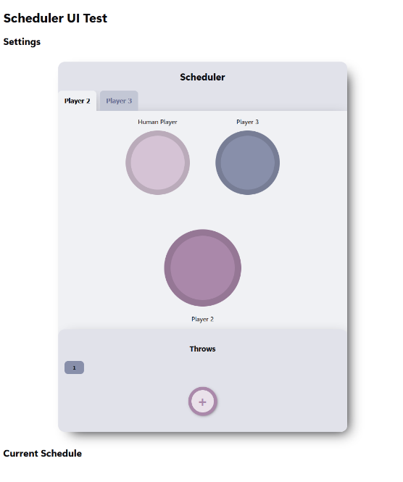
Figure 3. Mockup 2 Default State
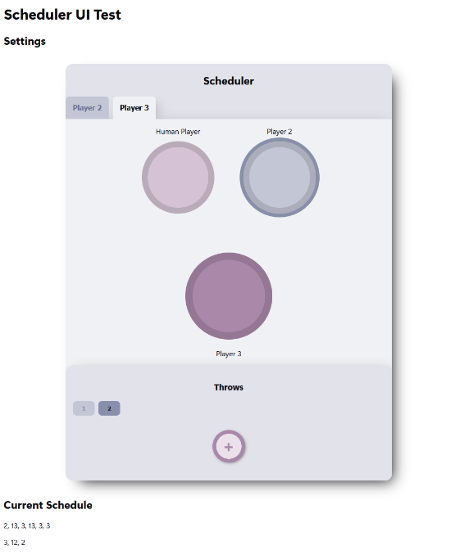
Figure 4. Mockup 2 with a CPU Player Selected from the Player 3 Tab
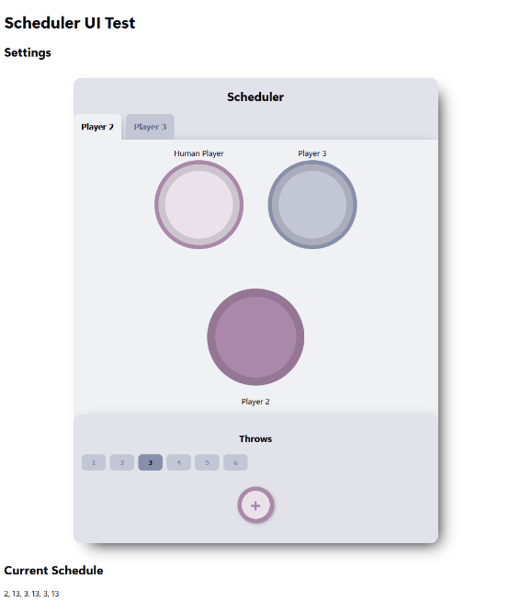
Figure 5. Mockup 2 with Human and CPU Players and with Multiple Throws

